# Serverless API backend application

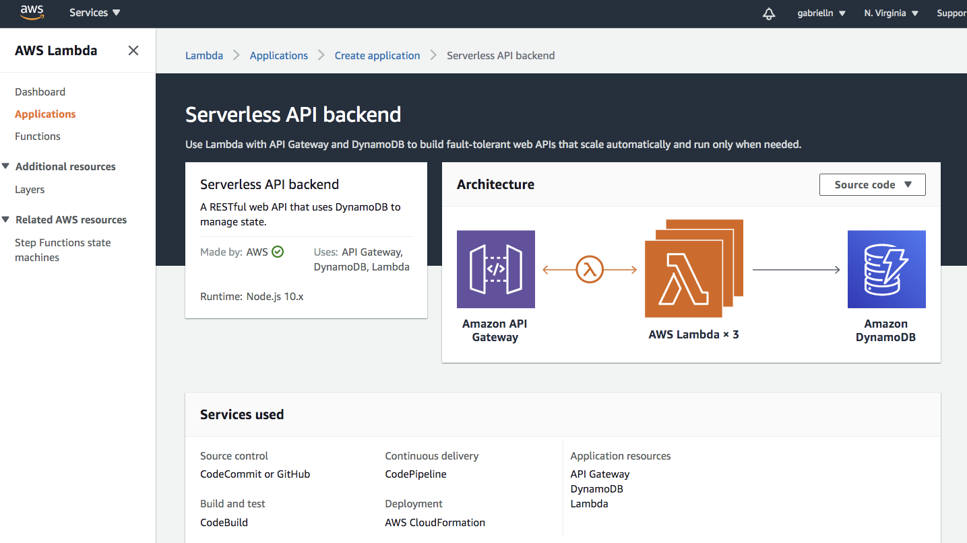

<https://github.com/simalexan/s3-lambda-save-dynamodb>

# File Processing application

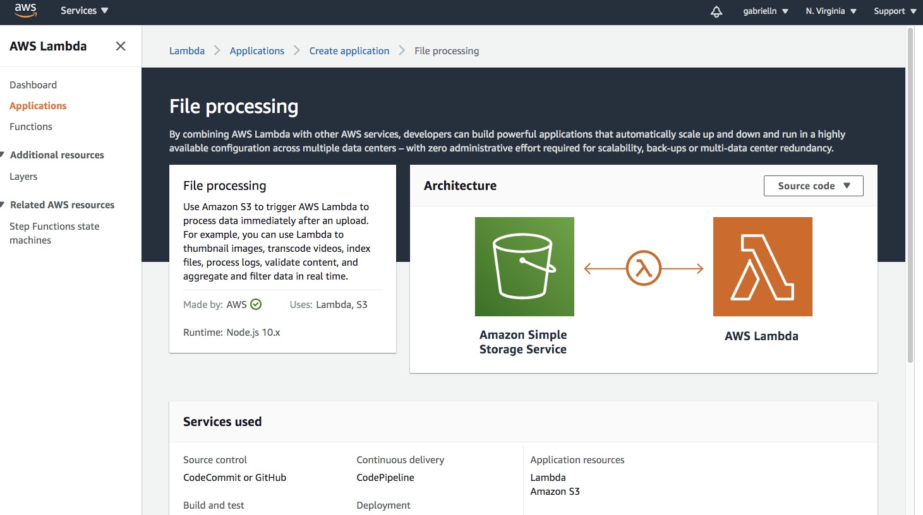

<https://console.aws.amazon.com/codesuite/codecommit/repositories/nfjsfileprocessing/browse?region=us-east-1>